**Creating Tasks and Worklist in Turn Over**

Select option 9 from TO menu to create a task.

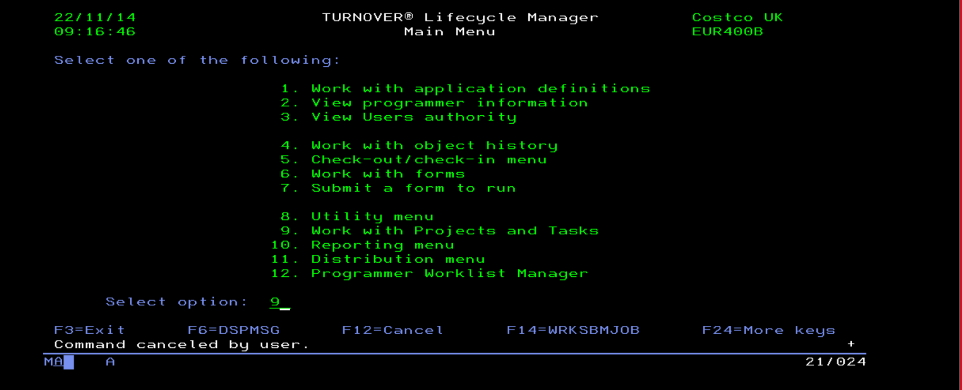

Option 1 against AGEN to add task.

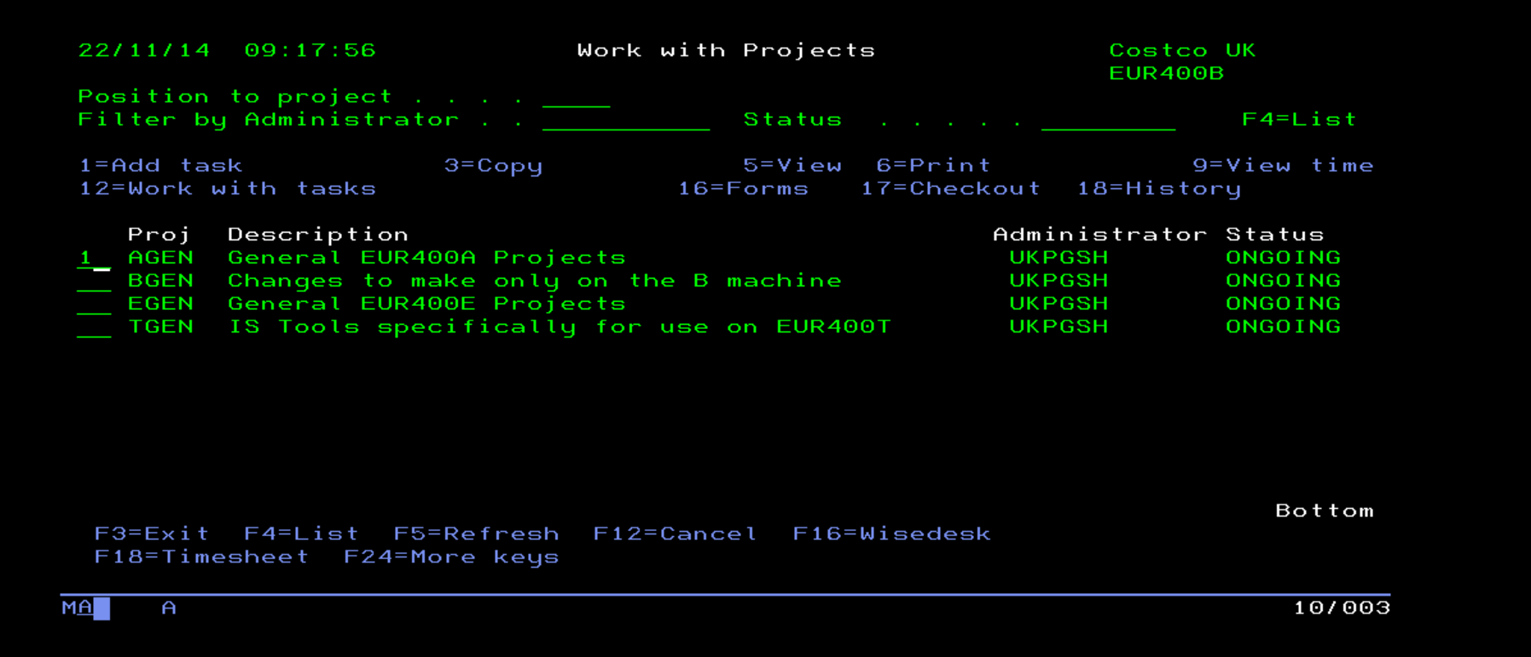

Fill the necessary fields as shown below and press enter. Select the relevant application based on the task you are doing.

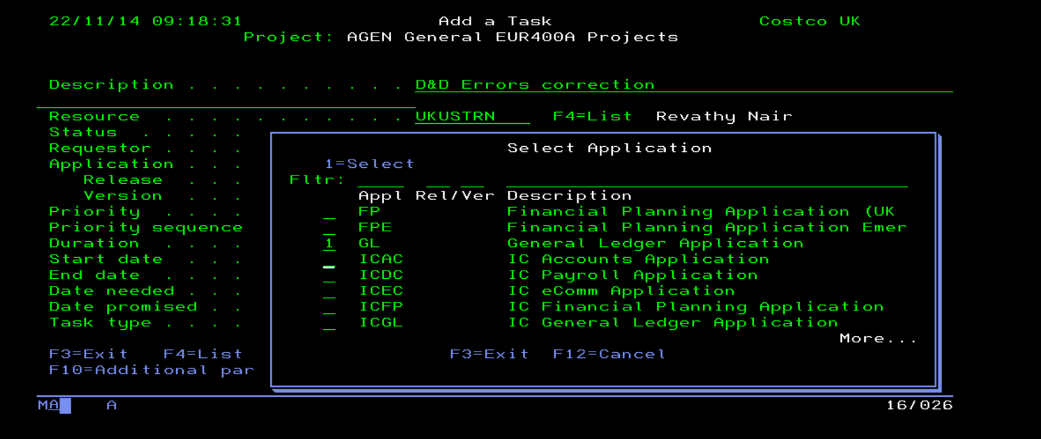

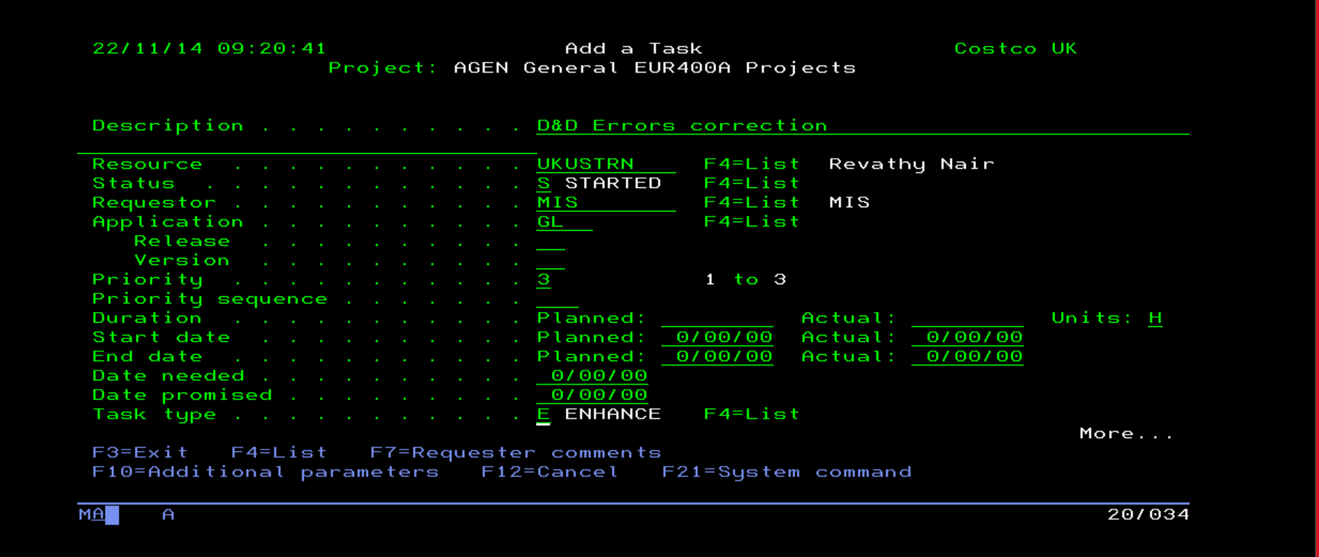

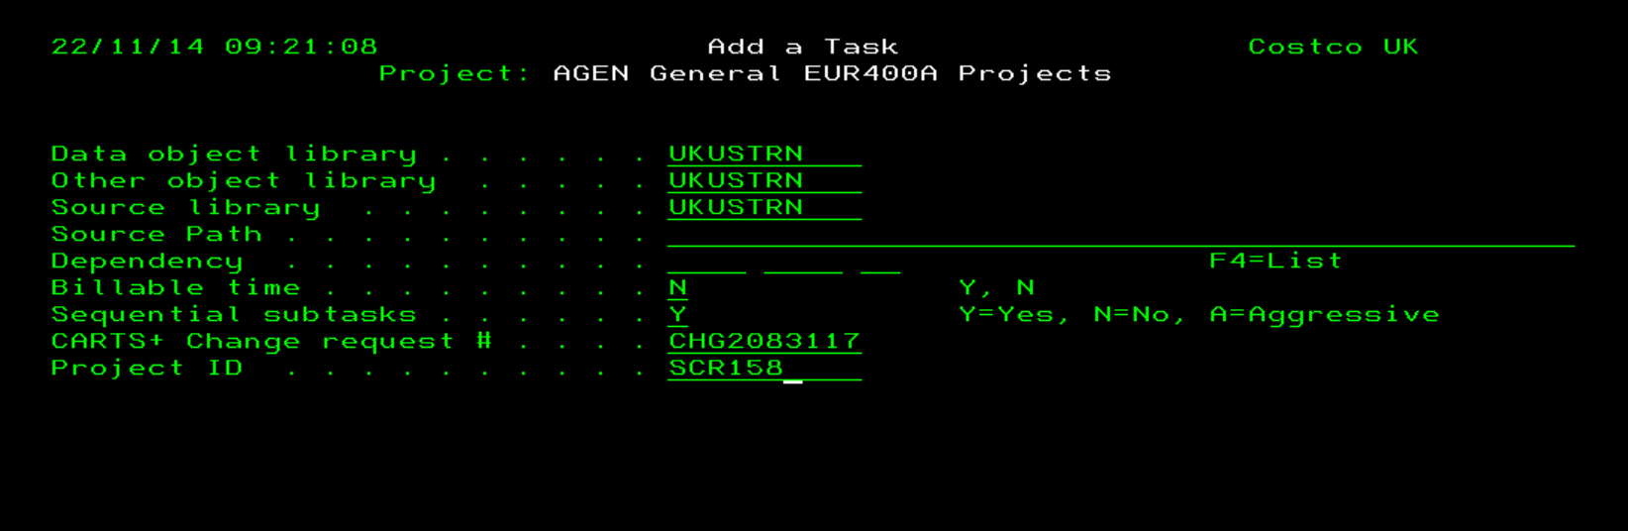

Task is created. Note the task number.

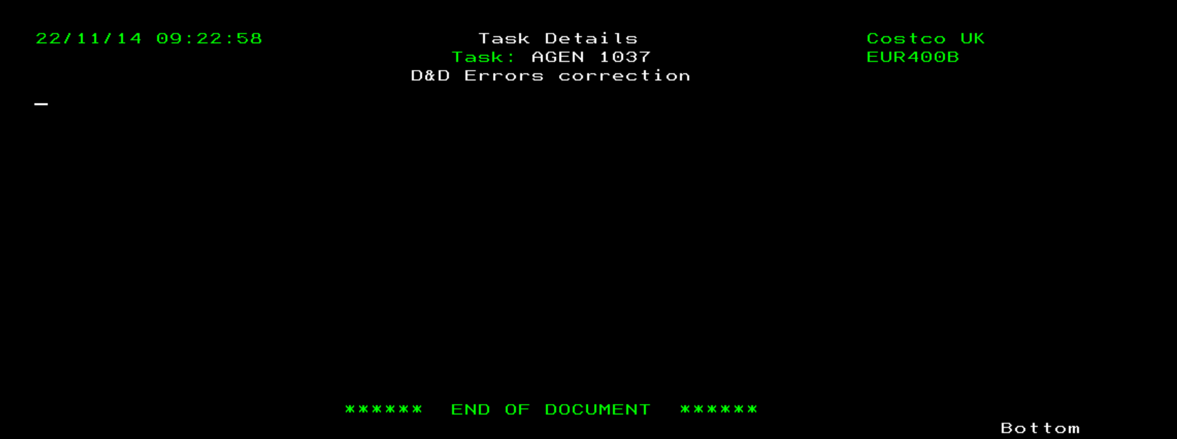

Go back to the work with projects screen. Select option 12 against AGEN to Work with task

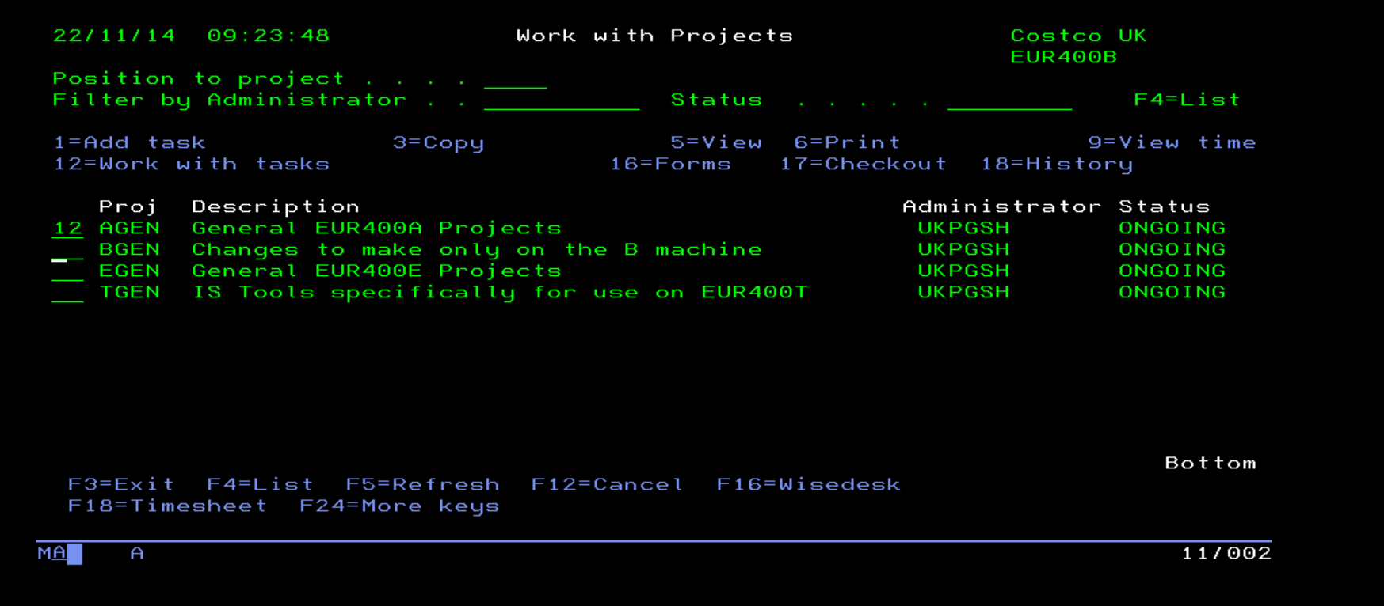

Position to the task number and select option 20, PWM to create work list.

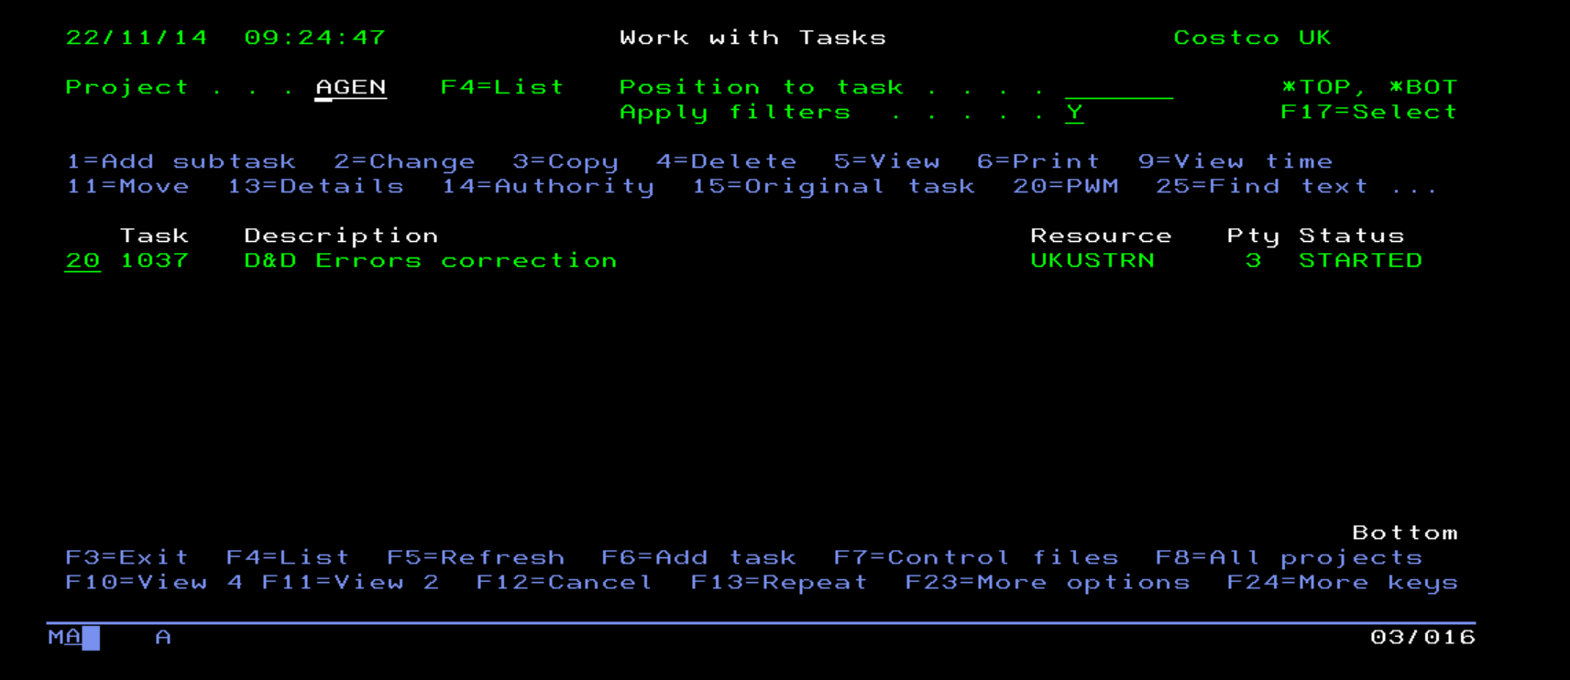

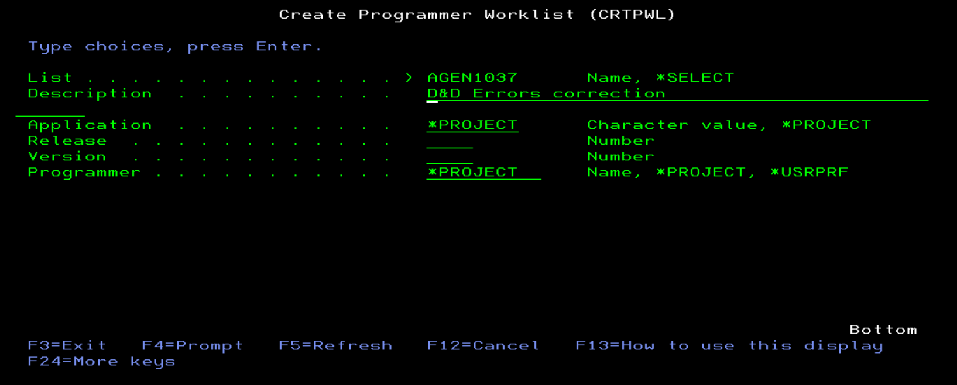

Work list is now created. F6 to add new items to the work list.

